INTRODUCTION

**Tableau** is a powerful tool used for data analysis, visualization. It allows creating amazing and interactive visualization and that too without coding. Tableau is very famous as it can take in data and produce the required data visualization output in a very short time. Basically, it can elevate your data into insights that can be used to drive your action in the future.

Empathy Map

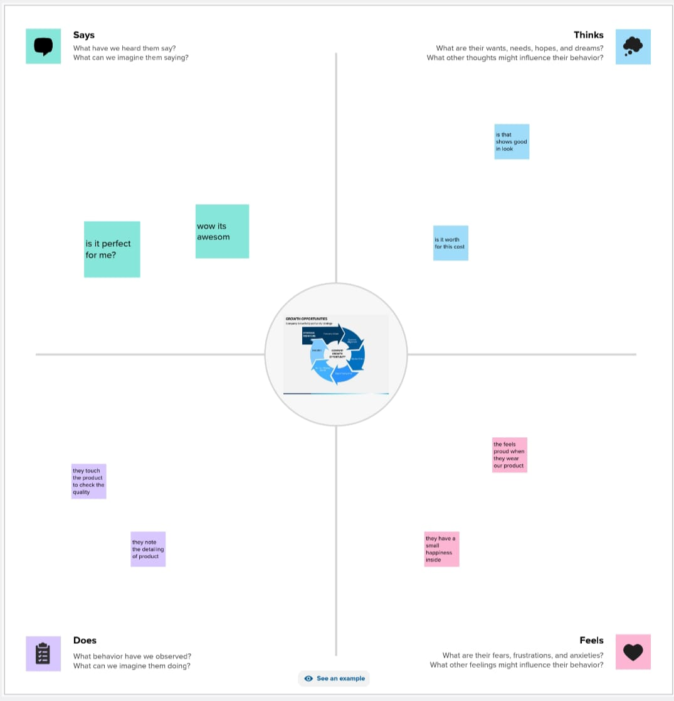

Brainstroming Map

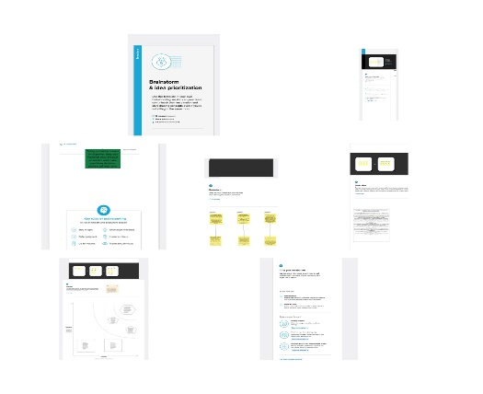

Result

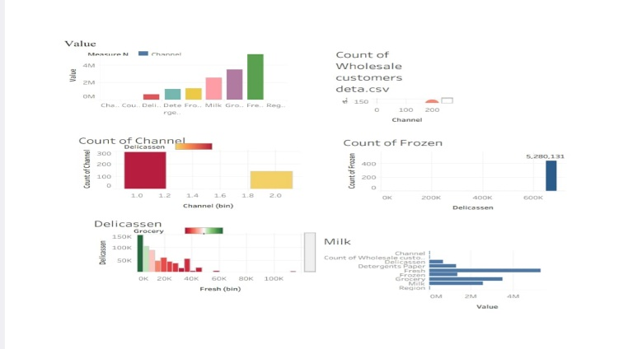

**Advantages of Tableau**

* **Quick calculation-** All the calculations on the tableau done by the backend, so it is relatively faster than any other tool.
* **Interactive dashboards**– Tableau dashboards are very interactive and easy to draw.
* **No manual calculation-**All the calculations done by the tableau only. There is no manual calculation but in some specific cases, we used calculated fields for calculation.

**A large amount of data-**Tableau can handle a large amount of data. Different types of visualization can be created with a large amount of data without impacting the performance of the dashboards.

**Disadvantages of Tableau**

* **High Cost-** tableau is a paid tool for visualization, and it is a reason why people are not using tableau so much.
* **Static and single value parameters-**Tableau’s parameters are static and always single value can be selected using a parameter. Whenever the data gets changed, these parameters need to be updated manually every time.
* **Limited Data Preprocessing-**Tableau is strictly a visualization tool. Tableau Desktop allows you to do very basic preprocessing.

**Conclusion**

Tableau is a software tool that provides a feature where you can transform your data into interactive dashboards. A combination of great analysis and storytelling, the data visualization tool removes noise from the background to help focus only on the essentials.

Tableau rests well with the security feature of the platform. The data that is shared across dashboards by various team members in the organization having its access- goes through a protected and safely entrusted environment.

**Future scope**

Tableau Dashboard

Collaborating and sharing Live and in-memory data

Data Source in Tableau.

Advanced Visualizations. Mobile view

Revision History. Licensing views

Subscribe

•Subcribe others.

• ETL Refresh and many more make Tableau one of the most famous data visualization tools.